Superstore Analysis Using Big Query

-- Query 1: View data

SELECT *
FROM `project-d97a927b-3883-4b21-835.superstore_analysis.sales_portfolio`
LIMIT 10;

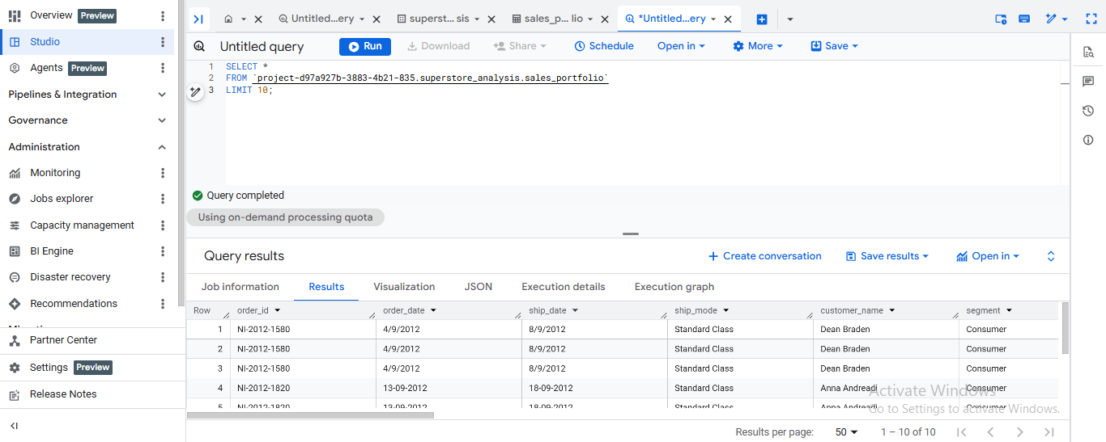

Insights:
The dataset has been successfully loaded into Big Query. The preview confirms the presence of key fields such as order date, customer name, sales, and product details. These variables will be used for further analytical queries.

-- Query 2: Total orders

SELECT COUNT(*) AS total_orders
FROM `project-d97a927b-3883-4b21-835.superstore_analysis.sales_portfolio`;

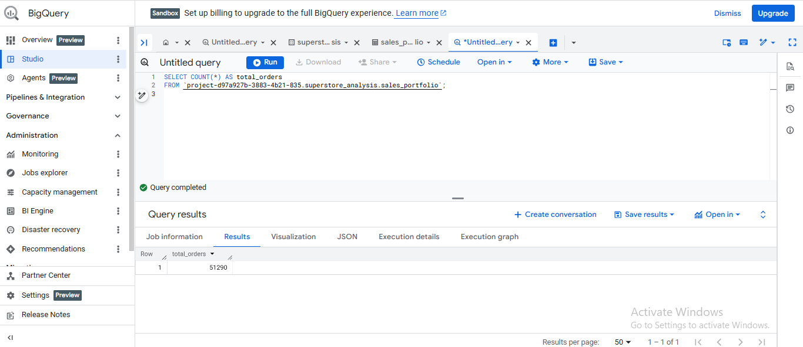

Insights:
The total number of unique orders in the dataset is calculated using the Order_ID field. This helps in understanding the overall transaction volume and forms the basis for further sales analysis.

-- Query 3: Total sales

SELECT ROUND(SUM(sales), 2) AS total_sales
FROM `project-d97a927b-3883-4b21-835.superstore_analysis.sales_portfolio`;

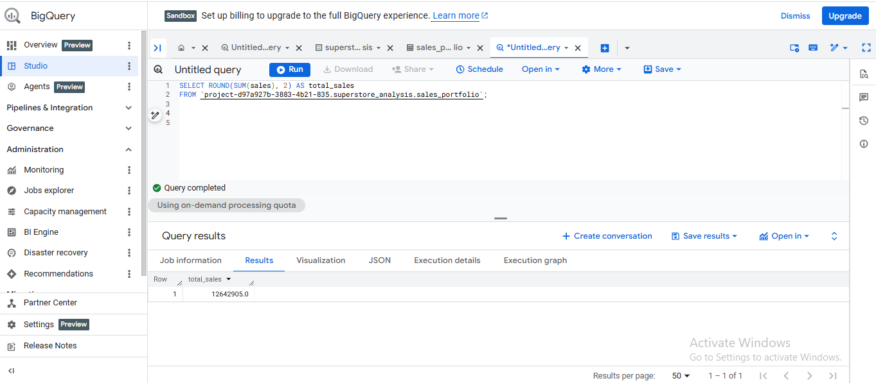

Insights:
The total sales value represents the overall revenue generated from all transactions in the dataset. This metric is essential for evaluating business performance and understanding the scale of operations.

-- Query 4: Total profit

SELECT ROUND(SUM(profit), 2) AS total_profit
FROM `project-d97a927b-3883-4b21-835.superstore_analysis.sales_portfolio`;

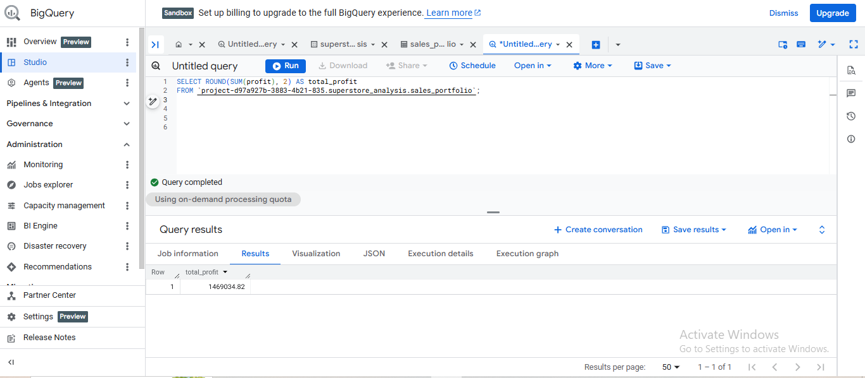

Insights:
The analysis shows total sales distribution across different product categories. By grouping the data by category, we can identify which segment contributes the most to overall revenue. This helps businesses focus on high-performing categories and optimize their product strategy.

Query 5: Top 10 Customers by Sales

SELECT Customer_Name, ROUND(SUM(Sales), 2) AS total_sales
FROM `project-d97a927b-3883-4b21-835.superstore_analysis.sales_portfolio`
GROUP BY Customer_Name
ORDER BY total_sales DESC
LIMIT 10;

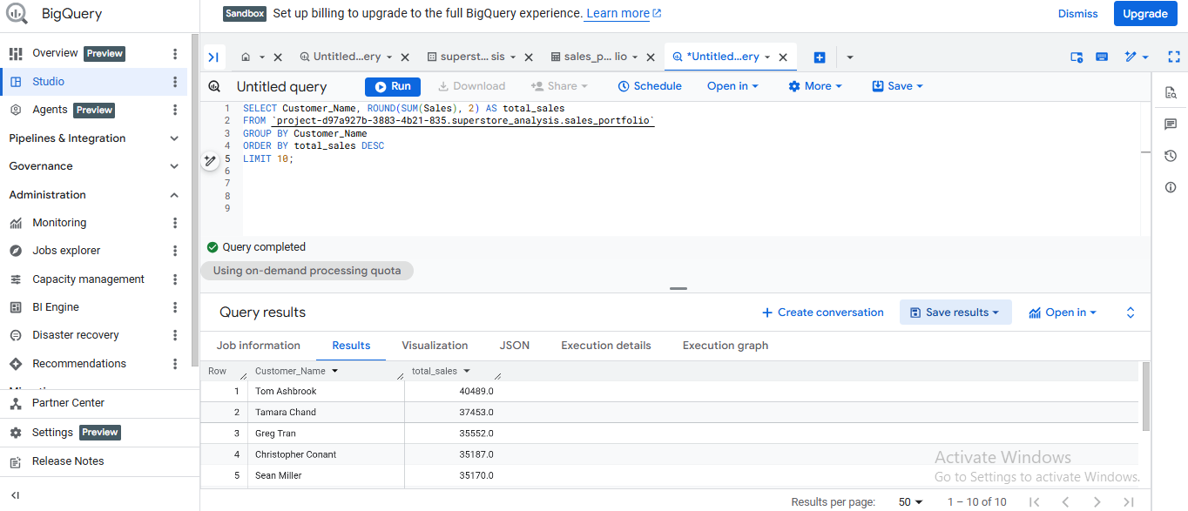

Insights:
This query identifies the top 10 customers based on total sales contribution. By analyzing customer-level spending, businesses can recognize high-value customers and develop targeted retention and loyalty strategies.

Query 6: Sales by Region

SELECT Region, ROUND(SUM(Sales), 2) AS total_sales
FROM `project-d97a927b-3883-4b21-835.superstore_analysis.sales_portfolio`
GROUP BY Region
ORDER BY total_sales DESC;

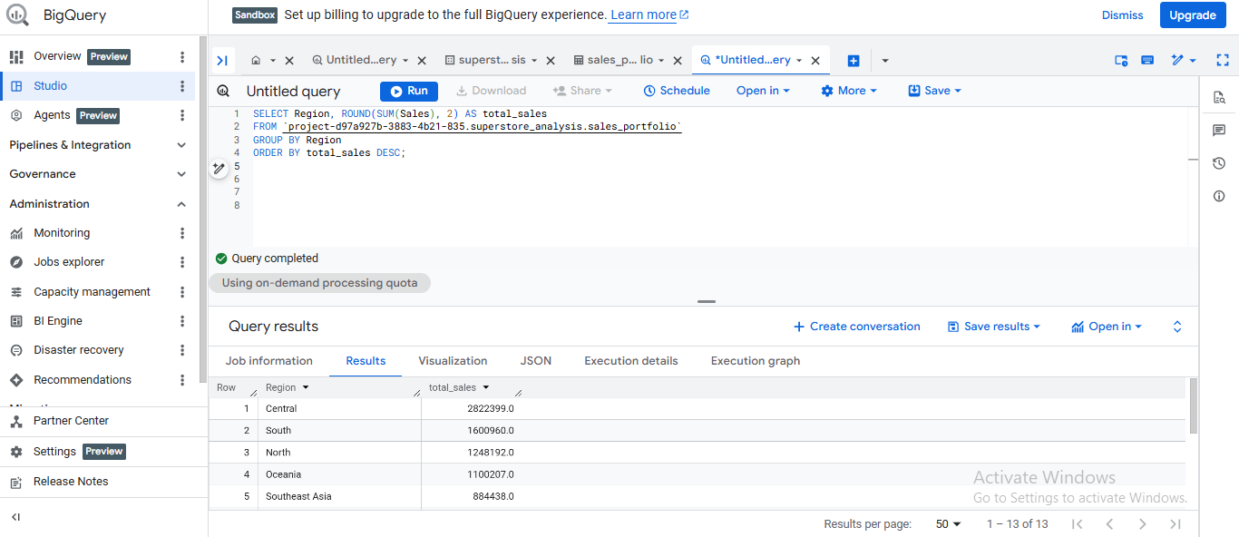

Insights:
This query analyzes total sales across different regions, providing insights into geographical performance. It helps identify high-performing regions and supports strategic decisions such as regional expansion, marketing focus, and resource allocation.

Query 7: Monthly Sales Trend

SELECT
EXTRACT(YEAR FROM PARSE_DATE('%d-%m-%Y', Order_Date)) AS order_year,
EXTRACT(MONTH FROM PARSE_DATE('%d-%m-%Y', Order_Date)) AS order_month,
ROUND(SUM(Sales), 2) AS total_sales
FROM `project-d97a927b-3883-4b21-835.superstore_analysis.sales_portfolio`
GROUP BY order_year, order_month
ORDER BY order_year, order_month;

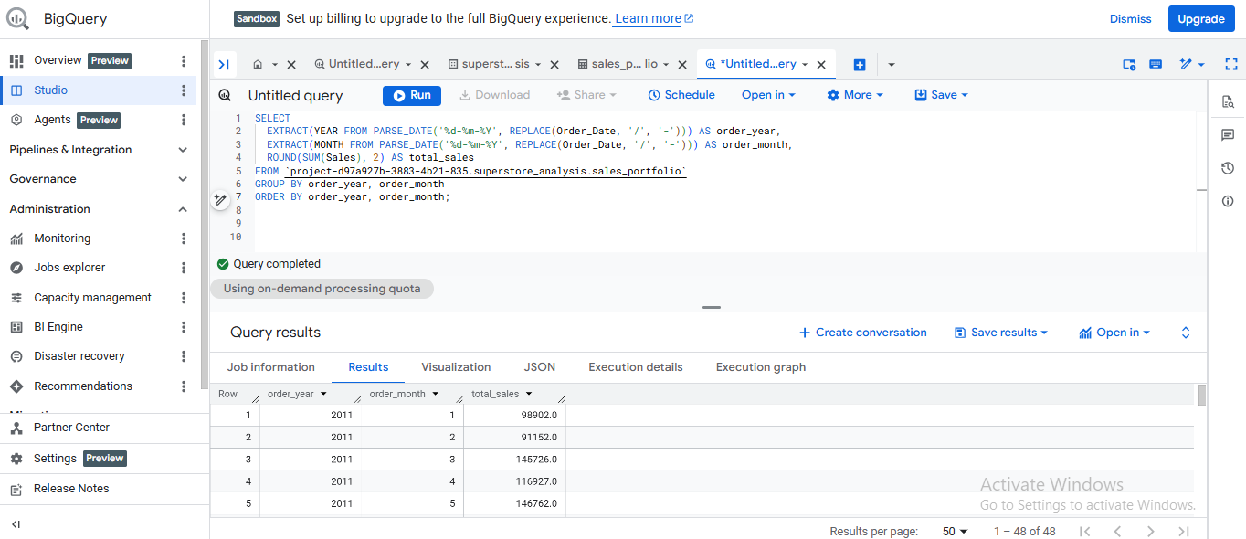

Insights:
The dataset contained inconsistent date formats (both '/' and '-'). To address this, the REPLACE function was used to standardize the format before applying PARSE_DATE. This ensured accurate extraction of year and month for reliable time-based sales analysis.

